**Section12**

CREATE OR REPLACE PROCEDURE drop_any_table(p_table_name IN VARCHAR2)

IS

BEGIN

EXECUTE IMMEDIATE 'DROP TABLE ' || p_table_name;

END;

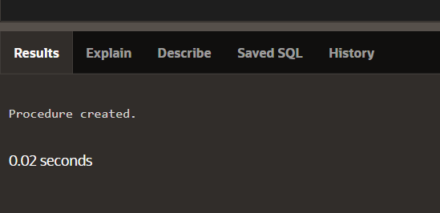

BEGIN

drop_any_table('EMPLOYEES');

END;

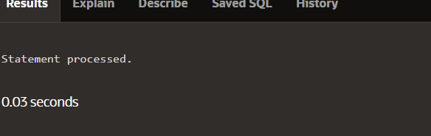

CREATE FUNCTION del_rows(p_table_name VARCHAR2)

RETURN NUMBER IS

BEGIN

EXECUTE IMMEDIATE 'DELETE FROM ' || p_table_name;

RETURN SQL%ROWCOUNT;

END;

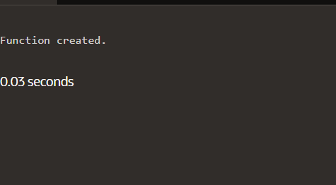

DECLARE

v_count NUMBER;

BEGIN

v_count := del_rows('employee');

DBMS_OUTPUT.PUT_LINE(v_count || ' rows deleted.');

END;

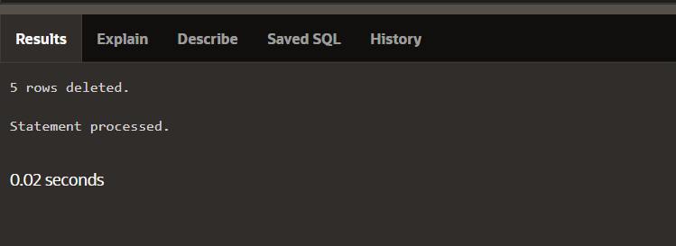

CREATE PROCEDURE add_row(p_table_name VARCHAR2,

p_id NUMBER, p_name VARCHAR2) IS

BEGIN

EXECUTE IMMEDIATE 'INSERT INTO ' || p_table_name ||

'VALUES(' || p_id || ', ''' || p_name || ''')';

END;

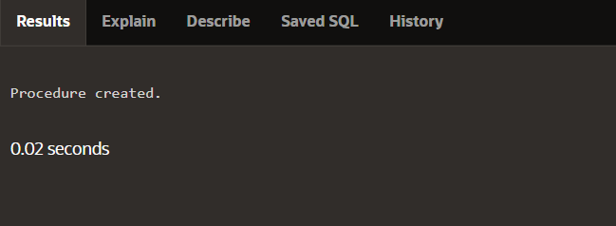

CREATE PROCEDURE compile_plsql

(p_name VARCHAR2,p_type VARCHAR2,p_options VARCHAR2 := NULL)

IS

v_stmt VARCHAR2(200);

BEGIN

v_stmt := 'ALTER ' || p_type || ' ' || p_name || ' COMPILE'

|| ' ' || p_options;

EXECUTE IMMEDIATE v_stmt;

END;

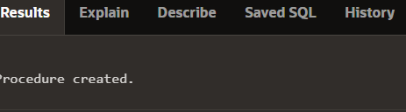

CREATE OR REPLACE FUNCTION del_rows

(p_table_name VARCHAR2) RETURN NUMBER IS

v_csr_id INTEGER;

v_rows_del NUMBER;

BEGIN

v_csr_id := DBMS_SQL.OPEN_CURSOR;

DBMS_SQL.PARSE(v_csr_id,

'DELETE FROM ' || p_table_name, DBMS_SQL.NATIVE);

v_rows_del := DBMS_SQL.EXECUTE(v_csr_id);

DBMS_SQL.CLOSE_CURSOR(v_csr_id);

RETURN v_rows_del;

END;

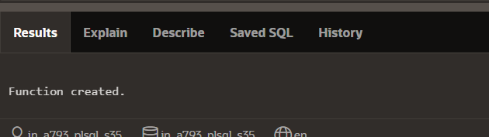

CREATE OR REPLACE PACKAGE emp_pkg IS

TYPE t_emp IS TABLE OF employee%ROWTYPE

INDEX BY BINARY_INTEGER;

PROCEDURE emp_proc

(p_small_arg IN NUMBER, p_big_arg OUT t_emp);

END emp_pkg;

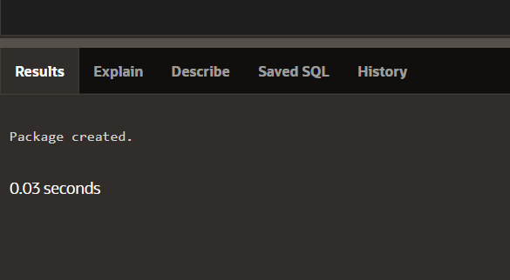

CREATE OR REPLACE PACKAGE emp_pkg IS

TYPE t_emp IS TABLE OF employee%ROWTYPE

INDEX BY BINARY_INTEGER;

PROCEDURE emp_proc

(p_small_arg IN NUMBER, p_big_arg OUT t_emp);

END emp_pkg;

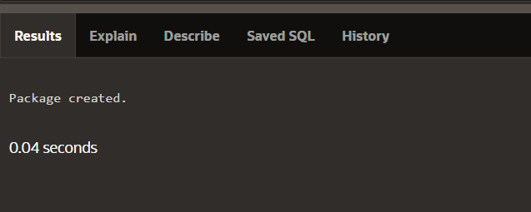

CREATE OR REPLACE PACKAGE emp_pkg IS

TYPE t_emp IS TABLE OF employee%ROWTYPE

INDEX BY BINARY_INTEGER;

PROCEDURE emp_proc

(p_small_arg IN NUMBER, p_big_arg OUT NOCOPY t_emp);

END emp_pkg;

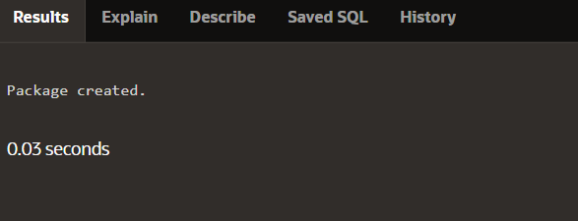

CREATE OR REPLACE PACKAGE emp_pkg IS

TYPE t_emp IS TABLE OF employee%ROWTYPE

INDEX BY BINARY_INTEGER;

PROCEDURE emp_proc

(p_small_arg IN NUMBER, p_big_arg OUT NOCOPY t_emp);

END emp_pkg;

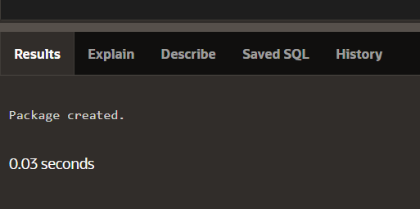

CREATE OR REPLACE FUNCTION twicenum

(p_number IN NUMBER)

RETURN NUMBER IS

BEGIN

RETURN p_number * 2;

END twicenum;

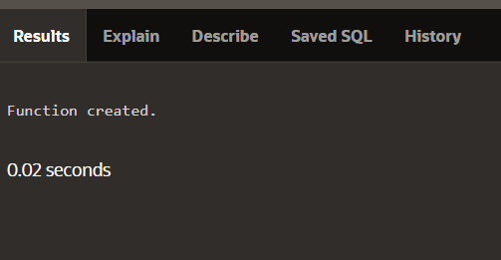

CREATE OR REPLACE PROCEDURE fetch_all_emps IS

TYPE t_emp IS TABLE OF employees%ROWTYPE INDEX BY BINARY_INTEGER;

v_emptab t_emp;

BEGIN

SELECT * BULK COLLECT INTO v_emptab FROM employees;

FOR i IN v_emptab.FIRST..v_emptab.LAST LOOP

IF v_emptab.EXISTS(i) THEN

DBMS_OUTPUT.PUT_LINE(v_emptab(i).last_name);

END IF;

END LOOP;

END fetch_all_emps;

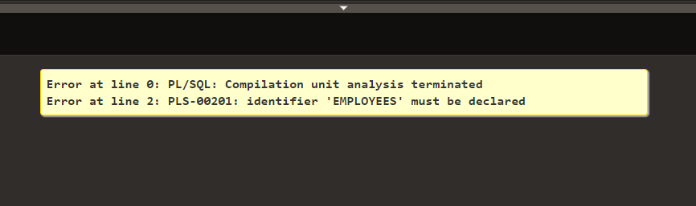

CREATE OR REPLACE PROCEDURE update_all_emps

(p_salary_raise_percent IN NUMBER) IS

TYPE t_empid IS TABLE OF employees.employee_id%TYPE

INDEX BY BINARY_INTEGER;

TYPE t_sal IS TABLE OF employees.salary%TYPE

INDEX BY BINARY_INTEGER;

v_empidtab t_empid;

v_saltab t_sal;

BEGIN

SELECT employee_id BULK COLLECT INTO v_empidtab FROM employees;

FORALL i IN v_empidtab.FIRST..v_empidtab.LAST

UPDATE employees

SET salary = salary * (1 + p_salary_raise_percent)

WHERE employee_id = v_empidtab(i)

RETURNING salary BULK COLLECT INTO v_saltab;

END update_all_emps;

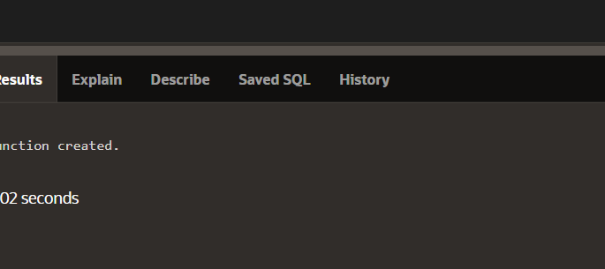

CREATE OR REPLACE PROCEDURE update_one_emp

(p_emp_id IN employees.employee_id%TYPE,

p_salary_raise_percent IN NUMBER) IS

v_new_salary employees.salary%TYPE;

BEGIN

UPDATE employees

SET salary = salary * (1 + p_salary_raise_percent)

WHERE employee_id = p_emp_id

RETURNING salary INTO v_new_salary;

DBMS_OUTPUT.PUT_LINE('New salary is: ' || v_new_salary);

END update_one_emp;



CREATE OR REPLACE PROCEDURE update_one_emp

(p_emp_id IN employees.employee_id%TYPE,

p_salary_raise_percent IN NUMBER) IS

v_new_salary employees.salary%TYPE;

BEGIN

UPDATE employees

SET salary = salary * (1 + p_salary_raise_percent)

WHERE employee_id = p_emp_id;

SELECT salary INTO v_new_salary

FROM employees

WHERE employee_id = p_emp_id;

DBMS_OUTPUT.PUT_LINE('New salary is: ' || v_new_salary);

END update_one_emp;

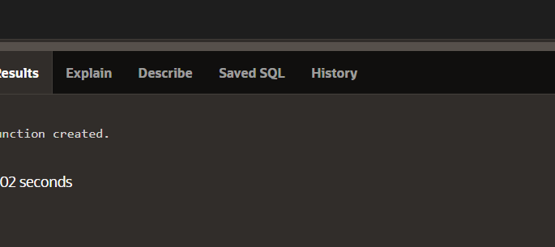

CREATE OR REPLACE PROCEDURE insert_emps IS

TYPE t_emps IS TABLE OF employees%ROWTYPE INDEX BY BINARY_INTEGER;

v_emptab t_emps;

BEGIN

SELECT * BULK COLLECT INTO v_emptab FROM employees;

FORALL i IN v_emptab.FIRST..v_emptab.LAST SAVE EXCEPTIONS

INSERT INTO employees VALUES v_emptab(i);

EXCEPTION

WHEN OTHERS THEN

FOR j in 1..SQL%BULK_EXCEPTIONS.COUNT LOOP

DBMS_OUTPUT.PUT_LINE(SQL%BULK_EXCEPTIONS(j).ERROR_INDEX);

DBMS_OUTPUT.PUT_LINE(SQL%BULK_EXCEPTIONS(j).ERROR_CODE);

END LOOP;

END insert_emps;

